IFSM 305 CASE STUDY PROJECT 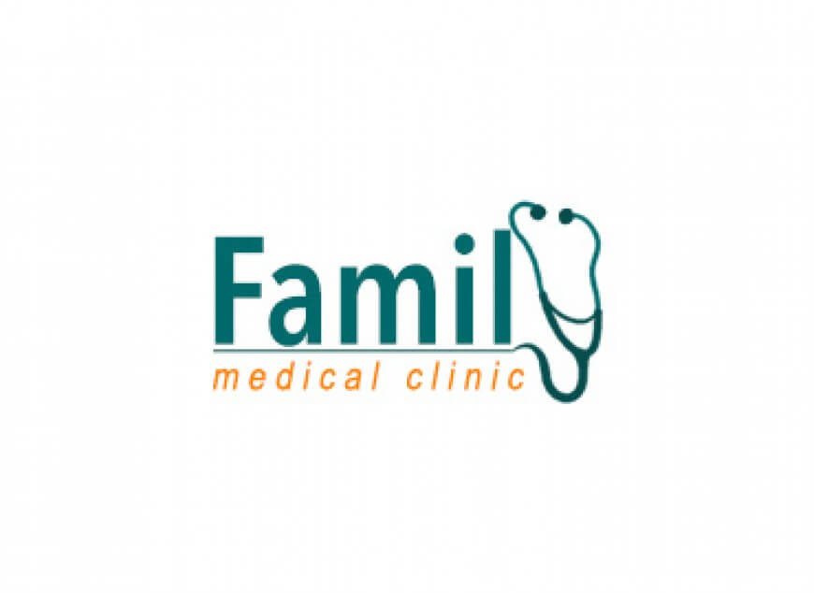
WASATCH FAMILY MEDICAL CLINIC CASE STUDY BACKGROUND
In 1980, the Wasatch Family Medical Clinic was opened in a growing family area near the Wasatch Mountains in northern Utah by Dr. Thomas Ute after he retired from the US Navy. WFMC is a small Family Medicine medical practice.
Dr. Ute has been the owner and manager of the medical practice since its inception. He has two nurses, Vivian and Andrea, to help him. Usually, one nurse takes care of the front desk while the other nurse assists the doctor during the patient visits. The nurses rotate duties each day.
Front desk duties include all administrative work including answering the phone, scheduling appointments, taking prescription refill requests, billing, faxing, and so on. If Vivian is helping the doctor on Monday, then it is Andrea who takes care of the front desk and all office work. Then, on Tuesday, Andrea will help the doctor and Vivian will take care of the front desk and office management work.
The two nurses are constantly busy and running around, and patients are now accustomed to a minimum 1-2 hour wait before being seen by the doctor. If one nurse is absent, the situation is even worse in the clinic. 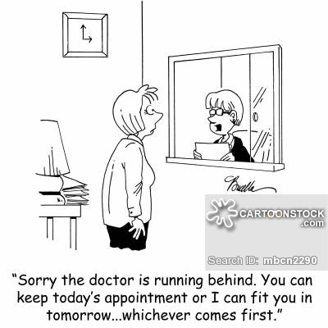
Currently, the clinic has three examination rooms, and Dr. Ute is now looking into bringing a new physician or nurse practitioner on board. This would help him grow his practice, provide better service to his patients, and possibly reduce the patients’ waiting time. Dr. Ute knows that this will increase the administrative overhead, and the two nurses will not be able to manage any additional administrative work. Because he faces several challenges and cannot afford to hire any additional office staff, Dr. Ute has to optimize his administrative and clinical operations. The practice is barely covering the expenses and salaries at the moment.
Dr. Ute’s practice operation is all paper-based. Paper medical records fill his front office shelves. The only software the doctor has on his front office computer is a stand-alone appointment scheduling system.
Billing insurance companies is done in a mostly manual way. To bill an insurance company, the front office nurse must send via FAX all the needed documentation to a third party medical billing company at the end of the day. The medical billing company then submits the claim to the insurance company and bills the patient. The clinic checks the status of the claims by logging into the medical billing system, through a login that the medical billing company has provided the clinic to access its account. There is no billing software installed at the practice, but the nurses open Internet Explorer to the URL of the medical billing company. They then use the login provided by the third party medical billing company. Of course, the medical billing company takes a percentage of the amount that the clinic is reimbursed by the insurance. Although the medical practice has one desktop PC with the scheduling software and an Internet connection, it does not have a website or any other technology, and essentially still operates the same way it did in 1980.
One problem that is immediately noticeable is that there is no quick way to check patients in for their appointments. If the nurse assigned to office duties is on the phone while a patient tries to check in, then the patient has to wait until she has completed her call. The doctor also may be waiting for the patient to be checked in, wasting valuable doctor time. In addition, many patients experience long waits on the phone when they are trying to schedule an appointment, while the nurse is checking in patients or responding to another patient’s request in the office.
Every year, the clinic requires its patients to complete a form with their personal and insurance information, rather than have them just verify what is currently on file. This annoys some of the parents when they have to complete all of this paperwork while taking care of their sick young child in the waiting room.
At the beginning of each day, the nurses pull the files for all patients who have appointments scheduled for that day. However, the clinic also accepts walk-in patients. When a walk-in patient or emergency case arrives at the office, the corresponding patient file must be located and pulled. 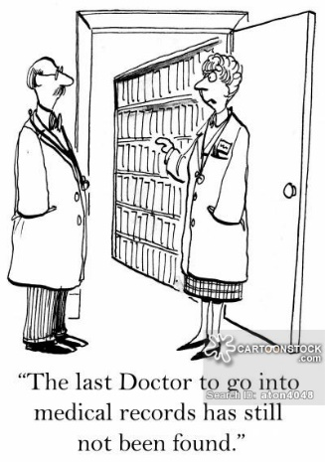
When a patient's laboratory test results are received in the office, the paper copy has to be filed in the patient's folder. Lost and misfiled reports are a big concern to Dr. Ute, as is his inability to quickly and easily share patient data when he makes a referral to a specialist.
Dr. Ute thinks that he and his staff are spending too much time handling paper and not enough time improving patient care. All of the medical records, lab results, and financial and payroll accounts are kept on paper. There is no quick way to look up a patient’s history or current prescriptions during office visits or when the doctor gets a call while he is away from the office
At a recent medical conference Dr. Ute learned about how Electronic Health Records (EHR) can be shared among health care providers to improve patient outcomes. After attending several demonstrations by the different vendors at the conference, he realized how inefficiently his practice is running and realized all the opportunities that EHR systems can bring. He recognizes many of the benefits of moving to Electronic Medical Records but feels very overwhelmed when considering how to start and what to do. He is also concerned about possible disruption to his practice which may negatively affect his patients’ care experience. Moreover, neither the doctor nor the nurses have any knowledge or experience when it comes to information technology.

Upon the recommendation of a fellow doctor, Dr. Ute has decided to hire an independent EHR Consultant, to help him select the best EHR system for his practice. His friend also advised him that he should not just buy any package from a vendor to automate his existing processes. Instead, he should have the EHR Consultant analyze the workflow processes at the practice first, then optimize the processes, and only then look at the various EHR systems. The new EHR system needs to work with the optimized processes of his practice. Dr. Ute needs to get his staff’s acceptance of and involvement in the process from Day 1, if the EHR adoption process is to succeed.

Dr. Ute realizes that EHR adoption may add significant costs to his practice, which he cannot afford. Therefore, he will go for the EHR adoption at this point only if he can find an affordable system. Based on his fellow doctor’s recommendation, Dr. Ute has contracted with an independent EHR Consultant, who is not associated with any vendor, to advise him through this process. Throughout this course you will be the EHR consultant.

Dr. Ute has several strategic goals in mind that he shares with you during your first meeting with him as his consultant. For one, he would like to see his medical practice operate more efficiently and make some financial profit that he could reinvest into the clinic in order to upgrade and expand the practice. In a few years, he will need to invest some funds in a major renovation, primarily in the examination rooms and the waiting area. If he had extra money, he could also rent the apartment next to his clinic and open up the space to make a larger clinic. If he did that, he could also expand the clinic into a 3-physician group practice and consider renting out some space to a physical therapy physician and generate some additional income. After much discussion with fellow MDs, he realizes that he can use technology to improve the quality of care, safety, and financial management decisions of his practice, while also meeting the legal and regulatory requirements for health care and health care systems. Implementing an EHR system for these purposes has now become another strategic goal for the practice.

Your task is to help Dr. Ute understand the process that occurs during a patient visit to the practice, how that process should be improved to make it more efficient, and then recommend a certified EHR system for him to implement. You are not expected to solve all of the problems identified or address all improvements that could be made at the Wasatch Family Medical Clinic.
The following is an example of how a process is identified and optimized using a technology solution:
Last year, the medical practice had no effective way to schedule appointments. The front desk nurse used a paper calendar to write in appointments. Obviously, as appointments were cancelled and rescheduled, the paper calendar became almost unreadable. It was also taking a long time for the nurse to record the patient name, phone number, and other critical information. At that point, Dr. Ute and his nurses decided to implement the scheduling system on the desktop PC. Now, the patients are all listed in the system, with the pertinent information, and the scheduler can quickly search for an open time and enter the patient's appointment on the schedule. This has significantly improved the scheduling process, but has done nothing to help with all of the other activities involved with a patient visit to the Clinic.
As you approach the Case Study assignments, you may find it helpful to think about your own experiences with a medical practice. Making a trip to a small medical practice may help you think about the processes, challenges, and opportunities.
STAGED ASSIGNMENTS
The Case Study and assignments address the Course Outcomes to enable you to:

- Evaluate the organizational environment in the health care industry to recognize how technology solutions enable strategic outcomes.

- Analyze the flow of data and information among disparate health information systems to support internal and external business processes.
- Evaluate technology solutions in the health care industry to improve the quality of care, safety, and financial management decisions.

- Examine the implications of ethical, legal, and regulatory policy issues on health care information systems.
Upon completion of these assignments you will have performed an array of activities to demonstrate your ability to apply the course concepts to a “real world situation” to:
- Analyze a clinical process and diagram the steps (Stage 1).

- Analyze the data flow among a clinical practice and external organizations (Stage 2).

- Propose an appropriate certified EHR technology solution (Stage 3).

- Identify and explain the requirements and legal, ethical and regulatory considerations for an EHR system (Stage 4).
The staged assignments are designed to follow the relevant chapters of the textbook and other readings in the course content, and are due on the dates as assigned in the class schedule. The grading rubric is included with each assignment.
These assignments are designed to help you identify how to effectively analyze and interpret information to improve a medical practice using technology. This is an opportunity for you to apply critical thinking skills and think like a professional medical consultant. When you are writing a paper or developing a presentation, prepare it as if it were going to the owner, Dr. Ute, whom you want to impress with your knowledge and abilities. Don't just go through the mechanics of pulling together information -- think about what you are doing, why you're doing it, whether it makes sense, whether the information seems realistic, and what the results show.
It is important that you identify relevant, timely resources that specifically support the points or information you provide in your assignment. You should read the source and assimilate the information first, and then put it into your own words and incorporate it into the flow of your writing, with appropriate in-text APA citations and a list of references at the end of your paper. It would be very unusual for an academic paper to have no references. Direct quotes should be used very sparingly—only when the author’s own words uniquely present a concept that would be lost if paraphrased by you.
One of the prerequisites for this course is that you have a fundamental working knowledge of word processing (MS Word) and presentation (MS PowerPoint) software. Detailed instructions for each Staged Project, 1 through 4, are posted in the Assignments area of the classroom. You are to prepare each assignment in the indicated format (such as a table, outline, report, presentation or other specified format) and submit it as an attachment through your individual Assignments Folder in LEO. It is the student's responsibility to ensure the assignment submission can be read using the specified file format.
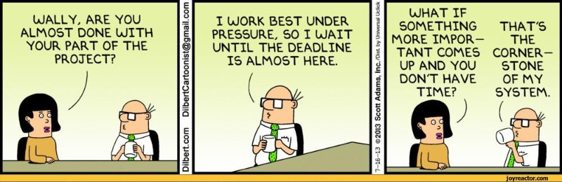
Do not wait until the last minute to begin an activity. You should read through all the assignments in advance to ensure you (1) understand what is expected, and (2) allow enough time to effectively create the information being requested. When you allow yourself enough time, you can access many resources, such as the Writing Lab, to help you complete the work.

